Utilities Smart Grid Report

Submitted By TechStone Technology Partners LLC



The structure, engineering and objectives of the world’s power systems are undergoing dramatic rethinking and significant change. New driving forces like climate change, novel market participants such as plug-in hybrid electric vehicles, and increasing energy demands are combining to drive the development of what is being referred to as the smart grid.
Many observers believe that the extent of change and its impact on societies could be on the same scale as the inception of the grid itself and will affect every single part of the power utility industry.
Around the world, governments and standards bodies at all levels are considering or adopting various foundational elements of the smart energy ecosystem:

- The European Commission has created an initiative called the European Technology Platforms (ETP’s) for creating the electricity networks of the future.
- China has announced an aggressive framework for smart grid deployment and is supporting it with billions of dollars.
- The International Electro technical Commission (IEC) is spearheading a global initiative to support the new "smart" electric power grids around the world with a comprehensive framework of common technical standards.
- The Institute of Electrical and Electronics Engineers (IEEE) is developing a Draft Guide for Smart Grid Interoperability of Energy Technology and Information Technology Operation with the Electric Power System (EPS), and End-Use Applications and Loads called IEEE P2030.
- In the United States, the National Institute of Standards and Technology (NIST) is leading the effort for developing a framework of Smart Grid standards for device and system interoperability.

The scope of the document is restricted to only addressing the integration challenges in the Utilities sector namely power.

- INDUSTRY TREND

Historically, the electricity grid has been an infrastructure deployed by utilities with the arguably “simple” mission of transmitting electricity from generators for distribution to customers. The basic electrical components that comprised the grid included objects such as generation plants, transformers, conductors, circuit breakers, fuses, switches, capacitors and machines.

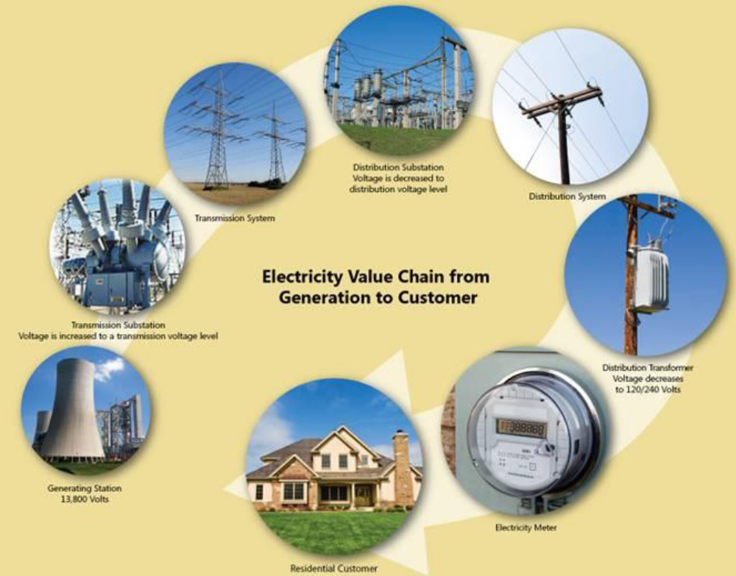
Figure 1 - Electricity Value Chain from Generation to Customer

This infrastructure is monitored and controlled by a set of devices that communicate with each other and various control centers through a field network.

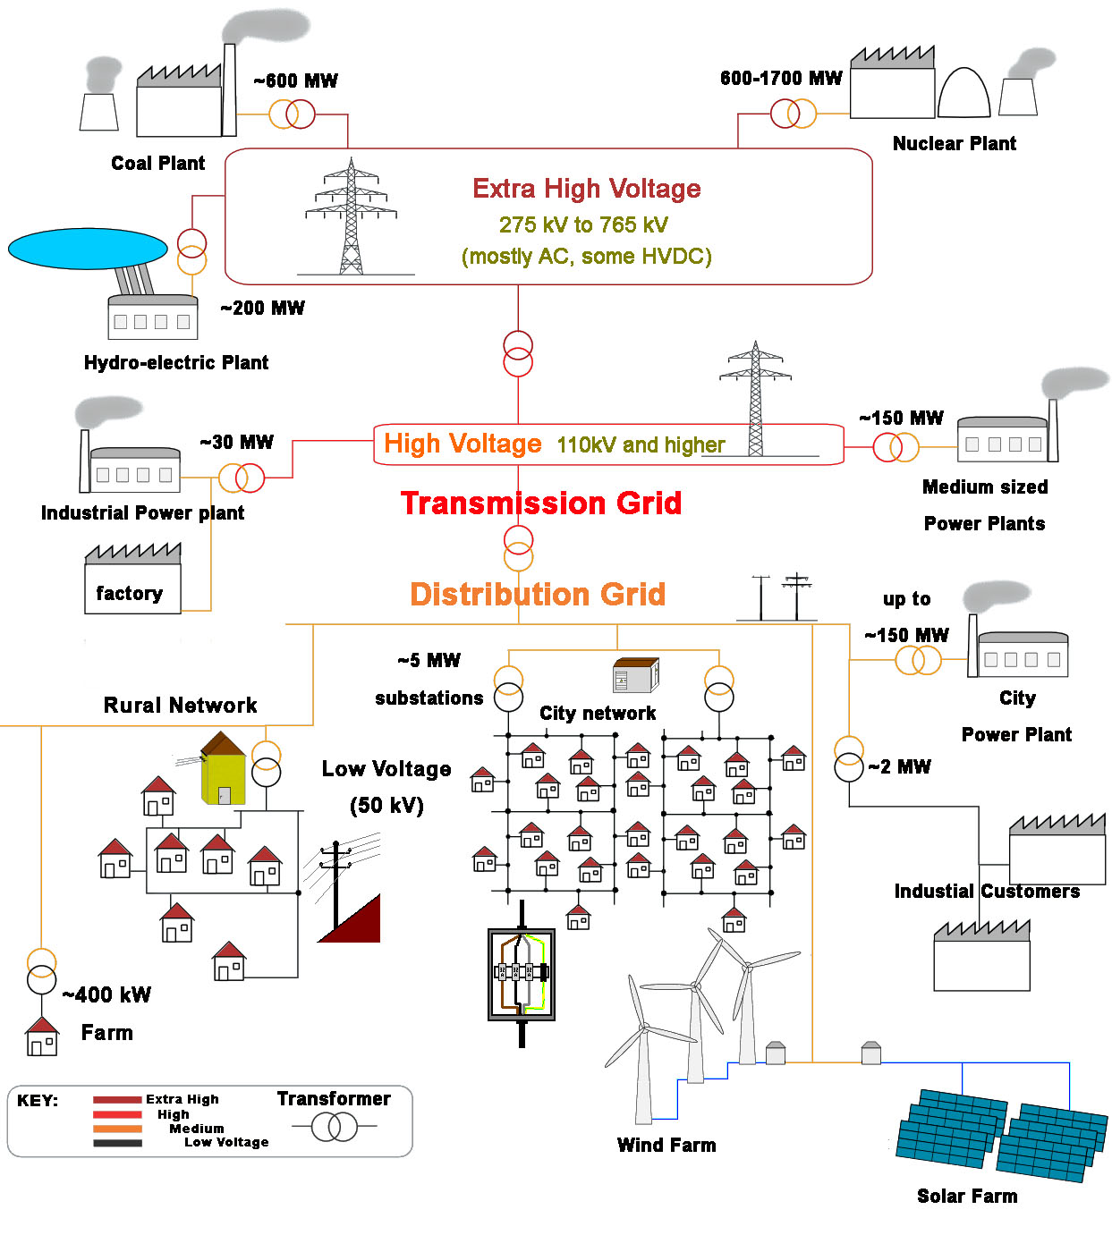
Figure 2 - Broader Perspective of Electricity Value Chain (Source: Wikipedia)

As technology has advanced with dramatic improvements in microprocessor, software and communications, these grid-enabling devices have been increasing in capability (and quantity) to the point that not only can they take measurements and respond to commands, but they also react independently and cooperatively with other devices in a coordinated manner in the field. This level of device-oriented collaboration has now extended past the substation to devices on feeders, to distributed resources, and to end-use customers.

As example, phasor measurement units (PMU’s) are just one important improvement in device capabilities that’s occurred as a result of advanced technology development. By using accurate GPS synchronized clocks, PMU’s are able to measure power frequency phase angles at many points on the grid, allowing for game-changing improvements in real-time monitoring and analysis of the grid. PMU’s will help with grid operation and visualization, as well as supporting reliable and automated incorporation of variable power sources like wind and solar into the grid.

As technology has advanced, so have industry standards. Funded by utilities, the Electric Power Research Institute (EPRI) led several efforts to address interoperability issues. The results were then advanced to the International Electro technical Commission (IEC) for standardization and led to the development of active users groups. These included the:
- Inter-Control Center Protocol (ICCP)
- Utility Communication Architecture (UCA)
- Common Information Model (CIM)

Other standardization efforts are worth mentioning as well:
- The IEEE, a professional association for the advancement of technology, has helped create many important communications and power engineering standards.
- In 2004, the U.S. Department of Energy (DOE) and the Grid Wise Alliance agreed to work together to realize the vision of a transformed national electricity grid in the United States.
- An effort from the International Council on Large Electric Systems (CIGRE) called D2.24 is driving requirements and architecture for next-generation energy market and energy management systems.
- Standards developed by the IEC and IEEE are now finding their way into NIST-led efforts related to the Smart Grid.
- Finally, as the Smart Energy Ecosystem evolves to include the end use consumer, either commercial or residential, Web services standards bodies such as OASIS will play a greater role.

- Emergence of the Smart Energy Ecosystem

A smarter grid comprised of these new or improved grid connected devices will enable the smart energy ecosystem to offer many new capabilities that respond to, as well as drive, changing consumer behavior and attitudes toward energy.

For instance, the smart energy ecosystem will likely need to accept power coming from the solar arrays on the rooftops of commercial buildings and private homes. It will also need to incorporate power coming from strong, but variable, wind farms. When millions of individuals own plug-in hybrid electric vehicles (PHEV’s), a smart energy ecosystem will conceivably allow them to buy electricity from the grid during late night, non-peak hours. Then, if the grid needs power during peaking events, the utility might draw from the stored power in those very same PHEV’s.

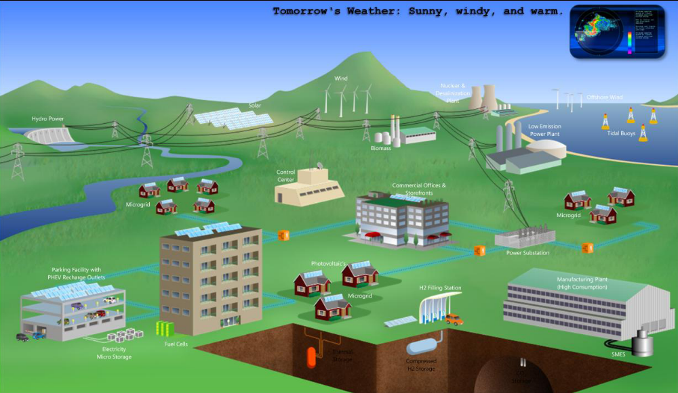

Figure 3 - A Smart Energy Ecosystem Driven by Innovation

Indeed, utilities are already deploying many devices with the microprocessors and two-way communication that will enable a wide variety of capabilities not possible before, including collection of more information, local decision-making and coordination.

- Participants within the Smart Energy Ecosystem

There is a wide and growing set of active participants within the smart energy ecosystem, each having its own roles, interests and associated responsibilities. Participants can be organizations, people and intelligent devices and include:

- Utilities and related companies, including:
  - Distribution companies
  - Independent System Operators (ISO’s)
  - Regional Transmission Operators (RTO’s)
  - Transmission market operators
  - Transmission companies
  - Generation companies
  - Distribution balancing authorities
- Service providers, including:
  - Energy aggregators
  - Maintenance service providers
  - Metering service providers
  - Weather forecasting
  - Retail energy providers
  - Equipment providers (PHEV’s, solar panels, storage, etc.)

- Customers, including:
  - Residential
  - Commercial
  - Industrial
  - Governmental

PJM Interconnection developed the following diagram to illustrate the different actors in the smart grid and how they communicate and collaborate to accomplish their various roles.

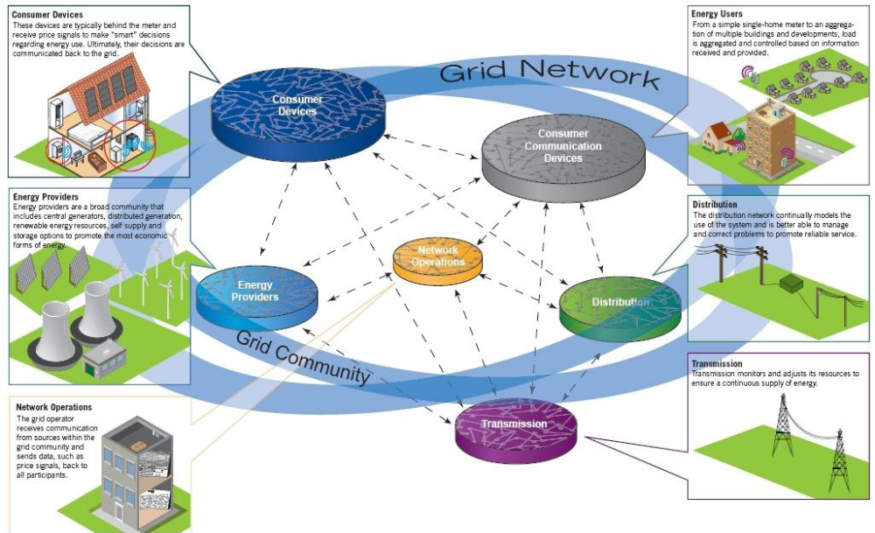
Figure 4 - Smart Grid Participants (Source: PJM Interconnection)

- Collaboration within the Ecosystem

By viewing the smart grid as an energy ecosystem, it becomes immediately evident that there is serious need for that grid to be enabled by collaboration between organizations and equipment.

Collaboration and associated business processes must occur between users, businesses, individual customers, and a variety of technology systems, resources and intelligent devices. Collaborative relationships may be cooperative or competitive. Utilities and market operators may cooperate to resolve a critical outage that threatens grid stability. Market participants may collaborate with the electricity market in a competitive environment.

Indeed, collaboration must occur for many purposes
- To operate the electricity grid
- To buy and sell energy through an energy market
- To cost effectively utilize energy
- To participate in energy (e.g. demand response, efficiency) programs to better manage use of energy
- Scheduling of resources
- Scheduling of consumption
- Settlement of accounts
- Maintenance of the electrical infrastructure

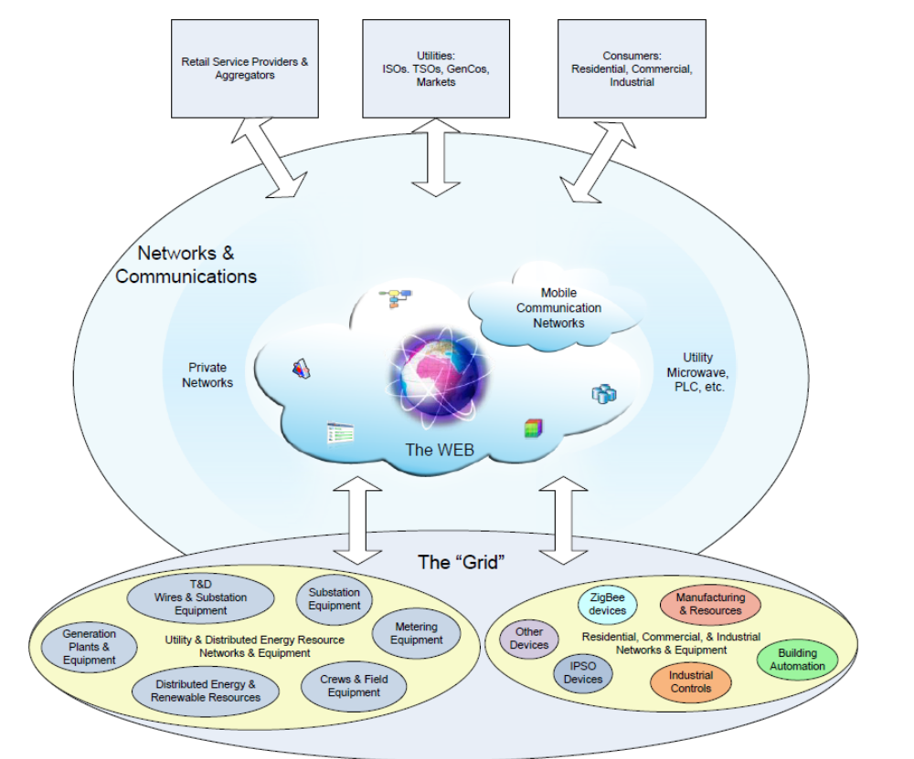

Figure 5 - Overview of the Smart Energy Ecosystem

Responsibilities within the ecosystem are federated, where there may be interactions between different types of organizations, as well as their interactions with the electricity grid and customer infrastructures. Some organizations may take on multiple roles, as in the case of a vertically integrated utility that may have combined responsibilities for generation, transmission and distribution. There also may be many types of service providers, such as those offering metering, maintenance, weather forecasts or load aggregation for participation in demand response programs.

In addition, all of them will need to interact and collaborate. Historically, participants have been people or organizations, but the capacity for local decision making by devices extends the participant/participation model.

- Changing Demands on the Business

The new smart energy economy will cause utilities and market participants to engage in a variety of new relationships and to adopt business models that will evolve as the shape of the smart grid becomes more evident and opportunities present themselves.

In fact, we believe these new relationships and changing business models will be one of the more interesting outcomes as the smart grid evolves. This new business environment will make it imperative to have a readily understood architecture in place to aid the capture of those opportunities as they arise.
This section considers:
- Energy Resources and Constraints
- Business Factors
- Technology Enablers

- Energy Resources and Constraints

The increasing diversity of energy resources will be one notable driver of new business models.
For example, while wind, solar and other forms of distributed energy generation are becoming common and more cost effective, they have far different operational, economic and control characteristics than conventional plants. Consider the operational complexity when a utility combines such variable generation sources with demand response, where the energy not used (sometimes referred to as a ‘negawatt’) can be considered an energy resource if demand can be controlled.

This new and very diversified generation model (of renewable, distributed generation and so-called ‘negawattage’) transforms the electricity grid from an operating model where power flows one way starting at a reasonably small set of generation plants, to that of a two-way flow with a mixture of a large number of small, medium and large energy resources, many having much more diverse operational characteristics. As mentioned previously, one extreme example of this dynamic will occur when the batteries in PHEV’s are used as storage for the grid, where they can be drawn upon as energy resources as needed during peak hours and then recharged during more cost effective off-peak hours.
Today though, the transmission grid has operational constraints that still need to be carefully managed. Distribution network constraints will become more apparent as consumers purchase more PHEV’s and deploy more distributed resources. Where a distribution feeder may have been designed for average customer loads of 1.5KW, the charging cycle of a single PHEV can add a load of up to 20KW. As more PHEV’s come onto the grid, they can easily exceed the capacity of a distribution feeder, requiring large scale physical upgrades and/or coordination of PHEV recharging. The utility will prefer the coordination option, in order to minimize peaks and provide for balanced operation of feeders within their designed limits.
Finally, new factors and their constraints are emerging around the basic utility function of metering. In the past, it was only possible to measure usage for all but large consumers on an aggregate monthly basis. With advanced meter deployments, it is now possible to measure usage for all customers in near real-time on an interval basis, where all customers’ usage may be reported every 15 minutes. Such interval reporting provides new opportunities to charge customers more for electricity consumption during more expensive peak hours, or provide reduced rates for usage during off-peak hours. This time-of-use pricing provides customers with the incentive to change their consumption behaviors and/or leverage devices within their home or business to rationalize overall energy costs. The communication infrastructure used for the advanced meter then becomes a gateway between the customer and utility or service providers for additional services including demand response, outage detection, power quality monitoring, etc.

- Business Factors

The wide variety of economic and technical changes that will occur with the advent of the smart energy ecosystem will require everyday business processes to increase in their ability and flexibility to adapt.
The new marketplace will offer many new opportunities to profit – if a company can change its business processes quickly and cost effectively. Such flexibility will require an information technology architecture that supports and anticipates each next stage of the evolution toward the smart energy ecosystem. The architecture’s value will be gained from the implementation’s cost effectiveness on the ongoing evolution of specific business process. In fact, that ongoing flexibility and capability to adapt will be the primary reason that an architectural framework is needed from the outset. The following industry issues demonstrate the challenges facing utility businesses and the technology solutions that may address them.

Utility Workforce Optimization
Like companies in other industries, utilities face mounting pressures to minimize the number of people needed to support their business processes. Whereas business process execution in the past may have required several persons with knowledge of specific applications, it is now possible to leverage workflow technologies to hide the underlying application details from users. Doing so can provide users with a simplified, streamlined view of the process so that it can be executed more efficiently, even with less training. Workflow technologies also automate many steps and avoid redundant data entry, improving accuracy and efficiency and ensuring that business process execution follows corporate compliance policies and procedures.

Workforce Demographic Changes
The architecture supporting the smart energy ecosystem will also need to consider and enable new dynamics occurring within the changing utility workforce. Much has been written about how the aging of the baby boomer generation will equate to senior resources – and their experience – leaving the workplace. In addition to the proverbial brain drain, a new workforce demographic will demand new work tools: the so-called millennial who are entering the workforce have heightened expectations for sophisticated tools they’ll be using to execute the utility’s work processes.

These dynamics will drive businesses to seek technology systems that will address both workforce demographic challenges. Those businesses that adapt the most quickly to these changing conditions will benefit more quickly. But in order to achieve this flexibility, people throughout the business will require timely access to information they need in a form they can use, through tools that create collaboration, knowledge management, data repositories and process integration. Businesses will need an architecture that is able to support pragmatic integration as an enabler of their evolution to the smart energy ecosystem.

Equipment Collaboration Optimization
Adding equipment to the grid also serves as an example of a process where workflow automation can facilitate the updating of planning and operations models, as well as asset management systems, geo-spatial information systems, and, potentially, customer information systems (in the case of phase rebalancing).

Outsourcing and Contracting Optimization
Utilities are now contracting new or outsourcing existing services from specialized service providers. This practice increases the need to shield enterprise applications from direct access, leveraging façade patterns that may be implemented using workflow or portal technologies. The outsourcing and contracting dynamic also creates need for location agnostic access, while at the same time highlighting the need for a robust multi-enterprise security infrastructure. Utilities might consider cloud services as a potential strategy if security and performance considerations are properly managed in the solution.

In sum, as customers leverage technical advances and rationalize their energy consumption, and as other outside factors affect how utilities must change their business operations, utility companies will need to leverage a variety of technical and business innovations to assist their journey toward a smart energy ecosystem.

- Technology Enablers

The technology architecture of the smart energy ecosystem won’t be confined to the need to revise business practices for workforce, consumer and regulatory changes. It will also need to be an enabler of new technologies, some we know about, and some that are yet to come.
Advanced Sensors and Web Integration
New, advanced sensors will expand the capabilities of the smart energy ecosystem with increased integration with the Web. These include:
- Global Positioning Systems (GPS)
- Phasor Measurement Units (PMU)
- Interval Meter Readings
- Centralized Remedial Action Schemes (C-RAS)

For instance, by leveraging technologies like GPS, it is now possible for devices to take measurements with a very precise view of time. This makes it possible to measure phase angles at locations on the grid using PMUs and to take grid-wide measurement snapshots. Interval meter readings will enable more accurate load models.

Together, these technologies provide new opportunities for improvements in network analysis, monitoring, and control, thereby offering improvements in grid stability and security, as well as facilitating better grid utilization.

Another example of advanced sensors and Web integration is C-RAS. Utilities have demonstrated that C-RAS can be used to create fast grid event mitigation schemes that can lead to material reduction in reserve margins while maintaining or improving overall reliability. The ability to automatically trigger pre-enabled grid response actions greatly enhances autonomous reliable grid operation.

Other core components of the smart energy ecosystem technology architecture will be the Web technologies, integration standards and related products that now offer increased collaboration at many levels. These technologies provide opportunities for more pragmatic, lower cost implementations and will overcome previous cost barriers to integration.

AMI and Communication Networks
Advanced metering infrastructures (AMI) is yet another important enabler that some people often consider synonymous with smart grid. Because of its two-way communication capabilities, AMI has created many new opportunities including:
- More timely measurement of usage, providing opportunities for new pricing options beyond billing that’s based on total monthly consumption.
- Automatic detection and confirmation of outages, with automatic verification of restoration.
- Detection of customer-level power quality issues, such as momentary outages and voltage levels.
- Providing a gateway to home area networks, such as those now provided using ZigBee, where home devices can react to pricing and load control signals as needed to implement demand response programs.

- Management of schedules for local energy consumption, where the user can minimize costs based upon their preferences and the utility can balance loads and make better utilization of the distribution networks.

Because of their role as an enabler of the smart energy ecosystem, communication networks should be considered a primary component in any architectural blueprint. The field networks currently used to communicate with AMI devices is typically private, often using proprietary or utility industry-specific protocols.

Alternatively, broadband internet services offer a communication infrastructure that is open, cost effective, higher bandwidth and already widely deployed. Because it is already deployed, it is already cost competitive with the lower performing utility-specific infrastructure. The recent FCC commitment to “net neutrality” removes the biggest remaining broadband concern. As long as security is addressed up front, metering and home area network (HAN) communications infrastructures allow new families of devices to be added to the set of monitored and controllable devices on the grid, including:

- Smart thermostats
- Smart appliances
- Plug-in hybrid electric vehicles (PHEV’s), which can be in states for charging, storage and discharging
- ZigBee2 Smart Energy (SE) profile devices
- Home Plug devices
- IPSO devices
- Residential solar and wind
- Building automation

A new generation of field and home devices that have the ability to make local decisions using two-way communication capabilities will allow customers to better monitor, control and schedule energy consumption, as well as respond to demand response events and pricing signals. Utilities or independent service providers could use these devices to extend their operational capabilities by facilitating registration of the devices in energy programs that permit the power provider to adjust schedules to provide more efficient and balanced operation of distribution networks.
New Computing Paradigms
New computing paradigms will require new approaches to the smart energy ecosystem. These paradigms include:
- Computing technologies
- Advances in storage
- Advances in communications technology
- Scale
- Participation of unreliable entities

For example, multiple cores in processors will be commonplace. Applications will need to transition to multi-core, multi-processor, multi-threaded design. Inexpensive, low-power, massive and parallel computing will dominate infrastructures and drive application design. Even while preserving existing investment through co-existence, application dis-aggregation will be necessary to capitalize upon new hardware platforms.

In addition, communication capacities – both wireless and hardwired – continue to expand. Indeed, bandwidth is expanding faster than Moore’s Law. However, the communication can be unreliable, either at certain times or geographic locations (commonly referred to as “cell holes”). Solutions will need to be flexible and resilient to momentary loss or interruptions of communication. As a result, autonomous operation will need to be a constant consideration.

The scale of connected smart energy systems will grow to new levels with the addition of the active participation of loads (end-use customers) and a multitude of tiny new devices. Tight coupling of unreliable autonomous participants will be proven unreliable. Systems will need to be designed to be flexible and adaptive to autonomous behavior. The true measure of success will be building a working system out of small autonomous independent unreliable devices and participants.

As a result, for some parts of the smart energy system, mastership cannot be assumed. The system will require design that should expect the same computing problem to be addressed in multiple locations. For example, micro-grids and integrated control centers may both calculate energy balancing of a given distribution segment:

- In the case of micro-grids, the solution can support effective operation of the micro-grids in the event of loss of control center communications.
- In the case of control centers, the solution can be coordinated between all neighboring feeders.

Real-time energy management systems, whether at the transmission or distribution levels, will continue to have rigorous performance and reliability constraints. The smart energy reference architecture recognizes that close coupling of all the new participants to the operation of the real-time systems will prove to be fragile and unreliable over the long term. Systems must be designed to be adaptive and resilient to autonomous, independent, potentially unexpected or non-responsive behavior of the new participants – whether at scale as in the case of end use residential customers, or in bulk such as large-scale renewable energy sources.

CHALLENGES POSED FOR SYSTEM INTEGRATORS

Various trends evolving over the period of time pose a varied challenge for system integrators, some of these are listed below.

- The incredible diversity of energy generation and delivery systems make it absolutely impossible and beyond human capability to coherently offer a single, detailed view of one particular architectural framework that will work in every single instance.
- Having an agile environment to cope up with the various changes in the industry.
PROPOSED ARCHITECTURE
The proposed architecture under discussion is an endeavor to come up with a reference architecture for Utilities with emphasis on power, It consists of different layers and the associated services depicted below (Because of paucity of space, Not all examples are depicted for each type of service).
The premise behind using this type of architecture is to have a solid foundation of services at various layers and in case they don’t exist incorporate in the existing reference architecture and update the architecture for future references, At some point of time the architecture would reach a maturity level where you only plug and play the appropriate services for changing the functionality.
This view also incorporates these features that make architecture complete and appropriate to business needs.

- Economic: The infrastructure must provide cost effective means to deploy and integrate functionality.
- Deployment: Components have to consider flexibility in how and where they can be deployed.
- Location agnostic: Services are designed so that they can be deployed on-premise or in the cloud.
- Always connected: Users and software components have access to platforms and services wherever they are located.
- Manageability: Infrastructure components can be efficiently deployed, managed and monitored.
- Transferability: Functionality and information can be migrated easily from one version of underlying infrastructure components to another with minimal interruption or intervention.

- Secure: Deployed components, functionality and associated information are protected from unauthorized access or malicious attacks.
- High performing and scalable: Support for more users, larger models, increased transaction volumes, etc. can be accommodated through increasing hardware performance (scale-up) or the linear addition of hardware and network resources (scale-out).
- Virtualization: Components can be deployed in a manner that optimizes the use of hardware resources.
- Highly available and self-healing: Support for transition to new equipment in the event of equipment failure.
- Disaster recovery and backup: Capability to move to a new platform or facility or recovery from a natural disaster or terrorist event and the back-up of results to facilitate the transition.

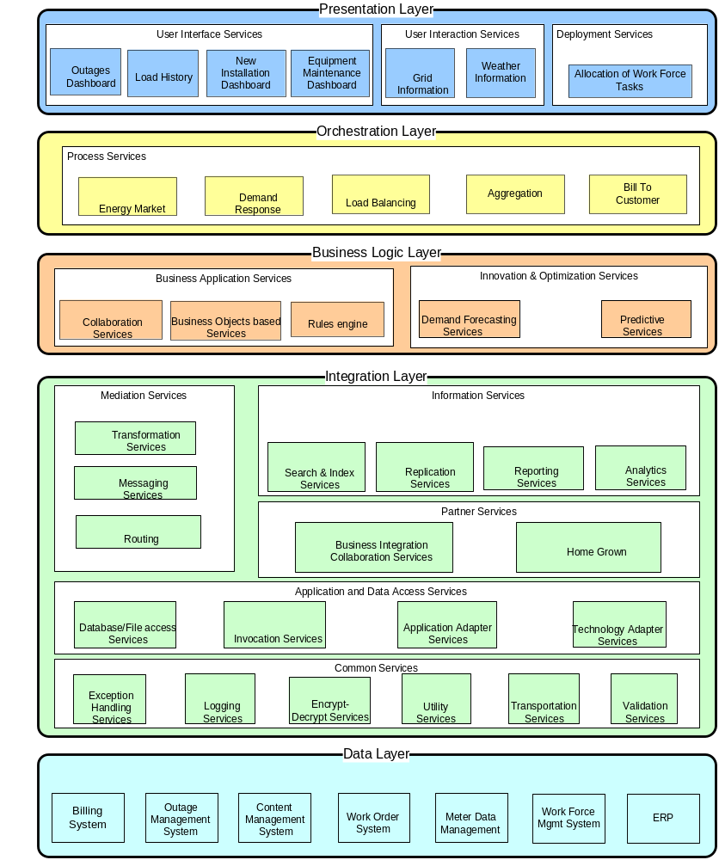

Presentation Layer
This layer consists of the application front-ends that are the active players. They initiate and control all activity of the enterprise systems. There are different types of application front-ends. An application front-end with a graphical user interface, such as a Web application or a rich client that interacts directly with end users, is the most obvious example. However, application front-ends do not necessarily have to interact directly with end users. Batch programs or long-living processes that invoke functionality periodically or as a result of specific events are also valid examples of application front-ends.
Nevertheless, it is entirely possible that an application front-end delegates much of its responsibility for a business process to one or more services. Ultimately, however, it is always an application front-end that initiates a business process.
Services
These services provide an entry point for users and the layer of abstraction between the interfaces and aggregates the information sources between the end user and the applications.
They are cataloged into three main services:

User interface services
Composed of a portal application that uses dashboards for decision-making, as well as visibility into operations.

Different services pertaining to energy sector that can be part of this service are:

- Outage dashboard.
- Load History.
- New Service Installation dashboard.
- Maintenance dashboard.
- Meter Usage.
- Outage history.
- Market transaction history.
- Load forecast.
- Generation schedules.
- Outage schedules.
- Equipment failures.
- Demand response event history.
- Market nodal prices.

User interaction services
Composed of visualization, collaboration, composite applications, alerts and forms.
Different services pertaining to energy sector that can be part of this service are:
- Power Grid analysis
- Power flow, where power, current and voltages are calculated for a point or node in the network.
- Contingency analysis to determine if the network will remain stable if one or more pieces of equipment fail.
- Outage analysis to determine the point of failure given a set of trouble calls and other inputs.
- Reliability analysis to determine the failure rates of certain types of equipment.
- Market analysis of customer responsiveness to demand response programs.
- Dynamic feeder loading analysis for customer energy usage at the distribution feeder level.
- Feeder analysis, where the voltage and loading characteristics of a given feeder can be studied.
- Real-time integration of weather information overlaying on the electricity grid.

Deployment services
Comprised of mobile, browser, and rich clients .These services use the support template components to easily create composite applications.
The composite applications:
Provide the basis for outsourced or in-house service applications
Support rich clients and mobile end-user clients
Provide highly customized and dynamic data, which gives real-time visibility that link results to the underlying business process metrics
Serve as a dashboard, providing users with a real-time view of key performance indicators (KPI’s) on the project

Different services pertaining to energy sector that can be part of this service are:
- Allocation of tasks to the mobile work force using mobile alerts or e-mail alerts.

Orchestration Layer
Compositions and choreographies of services are defined in this layer. Services are bundled into a flow through orchestration or choreography, and thus act together as a single application. These applications support specific use cases and business processes.

Services
The different service blocks possible with in this layer in the present day scenario are given below.

Process Services
These services use the business processes and mediation modules to accomplish its business flow requirements. Process services use the SCA programming model to model the business services that consume and produce business data.
A business process is the set of business-related activities, rules, and conditions invoked in a predefined sequence to achieve a business goal. Business rules are a means of implementing and enforcing business policy through externalization of business function. Externalization enables the business rules to be managed independently from other aspects of an application. This independence allows a dynamic business rules update capability, providing for a more agile business.
Different services pertaining to energy sector that can be part of this service are:

- Energy markets, where organizations will register resources and participate in the trading and settlement of energy in different markets.
- Aggregation, where a service provider will identify, register and manage a set of resources (e.g. distributed generation, controllable loads, etc.) and their participation in market programs.
- Demand response, where, as an extension of the energy market processes, devices may respond automatically to market pricing signals to take local actions related to energy usage.
- Load balancing, where load and available energy supply must be balanced. For example, the charging of plug-in vehicles may require coordination between devices (including vehicles) on the feeder, between devices within substations and with energy market dispatch schedules.
- Billing the customer, Where the customer meter is read and bill is calculated based on the consumption and the plan associated with the customer.

Business Logic Layer
This layer is about how the organizations gather and interpret data in order to make better business decisions and to optimize business processes. They make use of data, statistical and quantitative analysis, explanatory and predictive modeling, and fact-based decision-making.
These are used has input for human decisions; however, in business there are also examples of fully automated decisions that require minimal human intervention. Businesses, analytics (alongside data access and reporting) represents a subset of business intelligence (BI).

Services
The different service blocks possible with in this layer in the present day scenario are given below.

Business application services
Business applications services are loosely coupled to bring business value to the enterprise by using Web services. These are the services that use complex mathematical formulas on the data to predict and help users in making decisions.
Different services pertaining to energy sector that can be part of this service are:

Innovation & Optimization services
These services make use of data for statistical and quantitative analysis, explanatory and predictive modeling, and fact-based decision-making.
Different services pertaining to energy sector that can be part of this service are:
- Load-demand forecasting services.

Integration Layer
The integration layer can comprise of Message Oriented Middleware (MOM) which provides the ability to connect applications in a loosely coupled, asynchronous fashion and ESB, where services can be configured rather than coded. Process flow and service invocations can transparently span the entire distributed bus. An ESB provides a highly distributed integration environment that spans well beyond the reach of hub-and-spoke architectures, and a clear separation of business logic and integration logic such as routing and data transformation. ESB architecture forms an interconnected grid of messaging hubs and integration services, with the intelligence and functionality of the integration network distributed throughout.

Services
The different service blocks possible with in this layer in the present day scenario are given below.

Mediation services
These services form the crux of the messaging backbone helping the layer in transforming the data from one format to another, routing the messages based on the filters and rules and helping the applications in communicating both asynchronously and synchronously are using loosely coupled architecture.

Information services
Services that are used for transporting the data from source to target as well as massage the information for the services residing in business logic layer form part of these services

Application & data access services
The application and data access service component serves as the connectivity of services across heterogeneous technologies and formats. The business applications of most organizations must be able to handle a variety of data representations as they start moving toward integrating their applications.
Handling the myriad forms of data turns out to be a challenge; there is an imperative need for an interface that translates the data from one proprietary format to other and vice-versa.

Partner services
The partner services act as the entry point for external partners to integrate with the legacy systems and electronic data interchange (EDI) systems with the help of custom adapter’s thereby increasing operational efficiency and QoS. Adapters provide communication between the EIS and the integration broker. Each back-end system or business application requires a specific adapter.
Business integration adapters consist of a collection of software APIs, providing native communication with the back-end enterprise information system (EIS), and tools that let you configure business objects and adapters. Partner services using custom adapters depend on various software vendors.

Data layer
This encompasses all the applications that are part and parcel of running the business for the utility sector.

CONCLUSION

Author has endeavored to provide the view in this document of a reference architecture that articulates his vision for unified integration architecture for Utility sector. He recognizes that achieving this vision is a journey, and that few (if any) utilities have the luxury to implement this architecture in a Greenfield deployment. Further, partners are still developing their offerings to align with the tenants of the guidance of the reference architecture, so solutions will be forthcoming but may not exist today to fully implement this vision. To that end, utilities will need to establish a plan to migrate their infrastructure and solutions to align with the reference architecture.

ABOUT TECHSTONE

Techstone Technology Partners LLC is a leading Houston-based system integrator with expertise in deploying and integrating best of breed applications used in the Oil & Gas and Utilities industry.

